**Installation of Selenium IDE**

What you need

* Mozilla Firefox
* Active Internet Connection

If you do not have Mozilla Firefox yet, you can download it from <http://www.mozilla.org/en-US/firefox/new>.

**Steps**

Launch Firefox and navigate to <http://seleniumhq.org/download/>. Under the **Selenium IDE** section, click on the link that shows the current version number.

[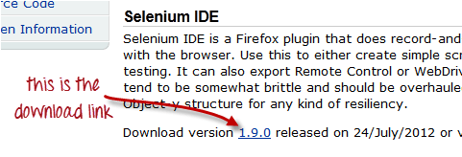](http://www.guru99.com/images/InstallIDE.png)

For [security](http://www.guru99.com/ethical-hacking-tutorials.html), a Firefox notification will pop up. Click on "**Allow**."

[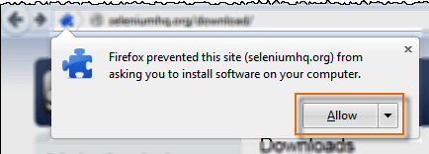](http://www.guru99.com/images/ide_install_-_firefox_prevent_-_allow_-_final.png)

Wait until Firefox completes the download and then click "**Install Now**."

[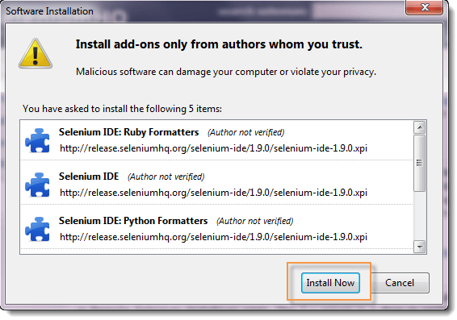](http://www.guru99.com/images/IDEInstall.png)

Wait until the installation is completed. In the pop-up window, click "**Restart Now**."

[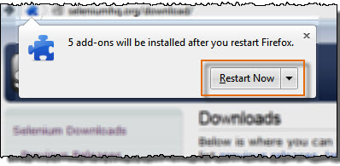](http://www.guru99.com/images/ide_install_-_restart_-_final.jpg)

After Firefox has restarted, **launch Selenium IDE** using either of two ways:

* By pressing **Ctrl+Alt+S**
* By clicking on the **Firefox menu button** > **Web Developer**>  **Selenium IDE**

[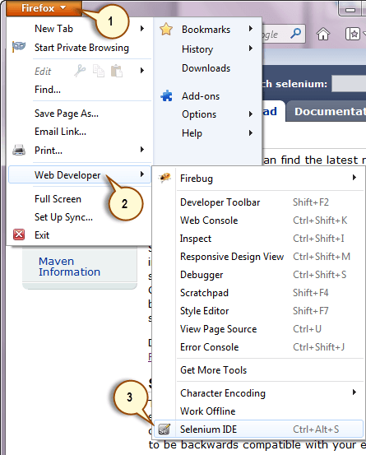](http://www.guru99.com/images/ide_-_launch_menu.png)

Selenium IDE should launch as shown below

[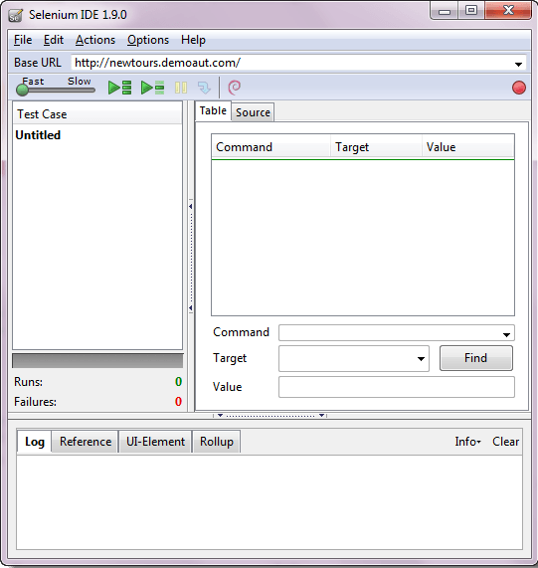](http://www.guru99.com/images/ide_-_launched.png)

**Installation of Firebug**

**Firebug**is a Firefox add-on that we will use to **inspect the HTML elements** of the web application under test. It will provide us the name of the element that our Selenese command would act upon.

**Step 1**

Use Firefox to navigate to Firebug's download page (<https://getfirebug.com/downloads/>) and click on the download link.

[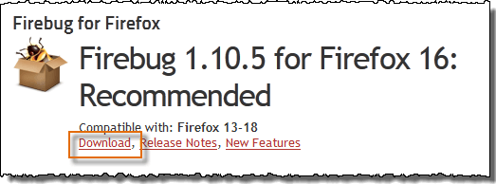](http://www.guru99.com/images/firebug_-_download_link_-_final.png)

**Step 2**

Firefox will take you to its Firebug download section. Click the **"Add to Firefox"** button.

[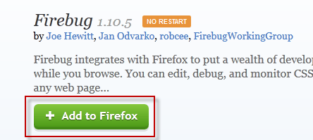](http://www.guru99.com/images/firebug_-_add_to_firefox.png)

**Step 3**

Wait for Firefox to complete downloading this add-on. On the dialog box that comes after, click **"Install Now."**

[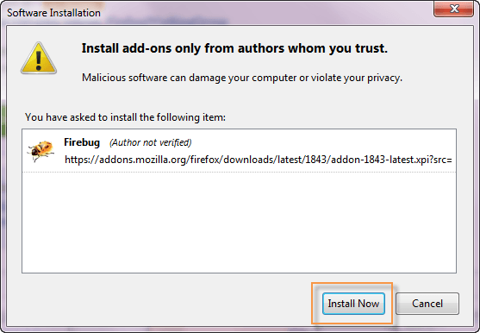](http://www.guru99.com/images/firebug_-_install_now.png)

**Step 4**

Wait for the installation to complete. A notification will pop-up saying, "Firebug has been installed successfully." You can immediately close this pop-up.

[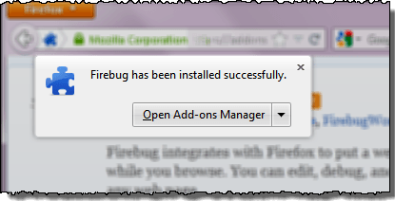](http://www.guru99.com/images/firebug_-_successfully_installed.png)

**Note**: In case if you do not see above pop-up, no worries! This pop-up appears for a few seconds and disappears.

You do not need to restart Firefox after installing Firebug.

**Step 5**

Launch Firebug by doing either of these two methods:

* Press **F12**
* Click on the **Firebug button** on the upper right corner of the Firefox window.

[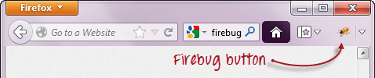](http://www.guru99.com/images/firebug_button.png)

**Step 6**

Firebug should launch **at the bottom of Firefox** as shown below

[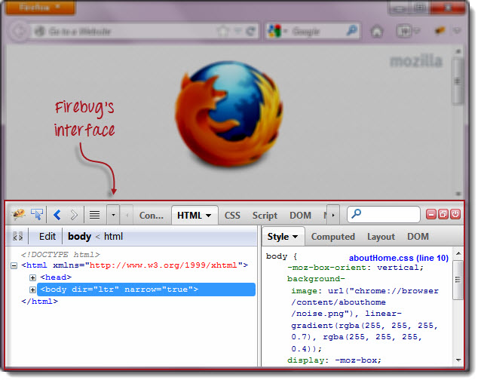](http://www.guru99.com/images/firebug_-_launched_-_final.jpg)

**Plugins**

**Selenium IDE can support additional Firefox add-ons or plugins created by other users**. You can visit [here](https://addons.mozilla.org/en-US/firefox/addon/selenium-expert-selenium-ide/)  for a list of Selenium add-ons available to date. Install them just as you do with other Firefox add-ons.

By default, Selenium IDE comes bundled with 4 plugins:

1.    Selenium IDE: C# Formatters

2.    Selenium IDE: [Java](http://www.guru99.com/java-tutorial.html) Formatters

3.    Selenium IDE: Python Formatters

4.    Selenium IDE: Ruby Formatters

These four plugins are required by Selenium IDE to convert Selenese into different formats.

**The Plugins tab shows a list of all your installed add-ons, together with the version number and name of the creator of each.**

[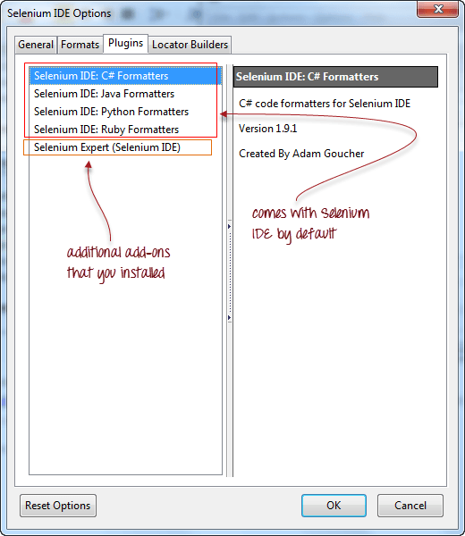](http://www.guru99.com/images/plugins_list.png)

**User Extensions**

Selenium IDE can support user extensions to provide advanced capabilities. User extensions are in the form of [JavaScript](http://www.guru99.com/interactive-javascript-tutorials.html) files. You install them by specifying their absolute path in either of these two fields in the Options dialog box.

* Selenium Core extensions (user-extensions.js)
* Selenium IDE extensions

[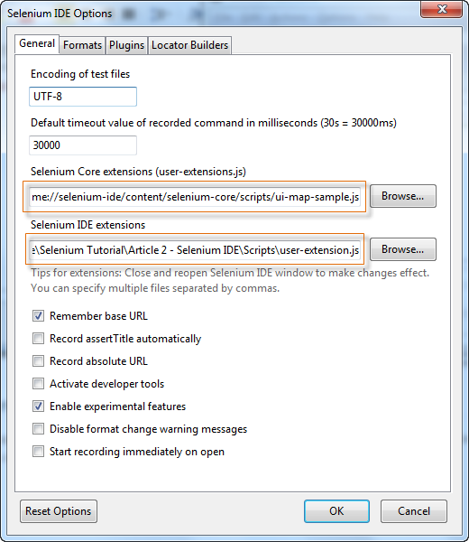](http://www.guru99.com/images/user_extensions.png)

You will be able to find tons of user extensions [here](http://wiki.openqa.org/display/SEL/Contributed+User-Extensions).